**Name: Hamza Mehmood Mughal**

**Intern ID: TN/IN02/PY/009**

**Task no:** **12**

**Question: Student record CRUD in dict.**

**Count word frequency in sentence.**

**Student record CRUD in dict:**

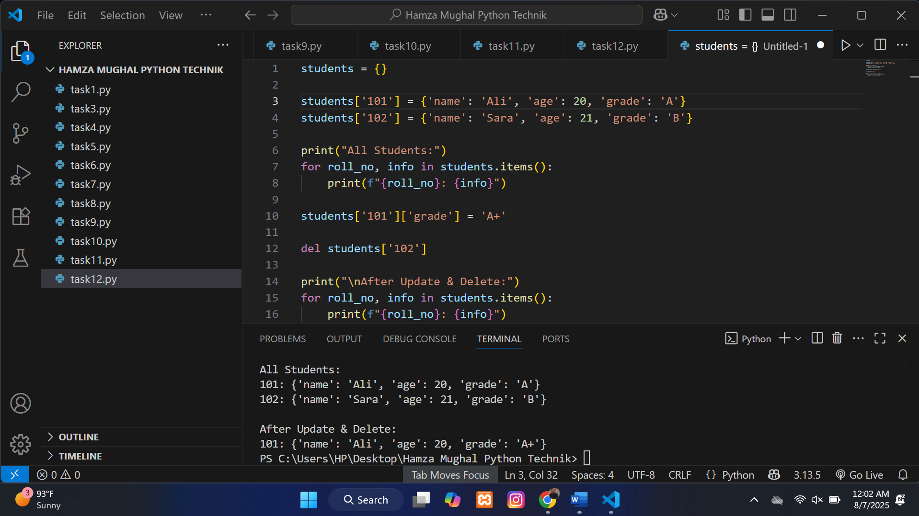

**Count word frequency in sentence:**

